@SpringBootApplication
@ComponentScan + @SpringBootConfiguration + @EnableAutoConfiguration

What is Component Scanning?
When a Spring Boot application starts, it creates a Spring Container (ApplicationContext).
After creating the container, Spring must answer one critical question:
Which classes should be converted into beans?
Spring cannot create beans from every Java class in the project.
So it needs to know where to look.
That is the job of Component Scanning.

Component Scanning is the process by which Spring:
- Searches certain packages
- Finds classes with Spring annotations (@Component, @Service, @Repository, @Controller)
- Creates objects for them
- Stores them inside the IoC container

Where Does Spring Start Scanning?
In a Spring Boot application, scanning begins from the main class.
Example:
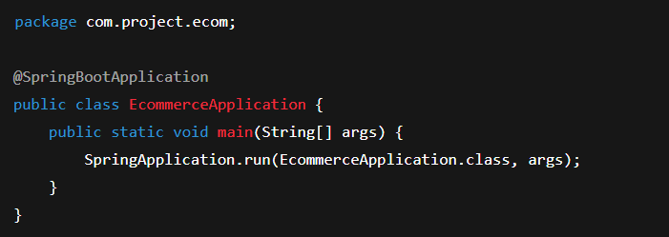
Spring will scan:
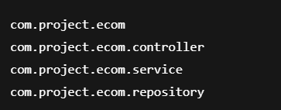
But not:

Because that package is outside the main class package.

Why Your Beans Are Sometimes Not Found
Imagine this structure:
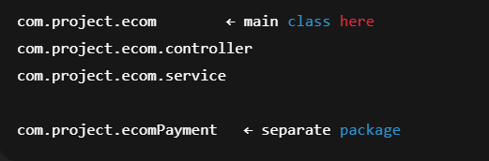
Spring will scan:

But it will ignore:

So beans inside ecomPayment will NOT be created.

Fixing This with @ComponentScan
Option 1 – Scan both explicitly
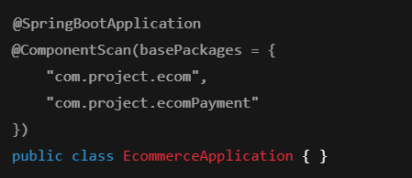
Now Spring scans both packages.

Option 2 – Scan root package
This scans everything inside com.project.

Using @Configuration for Component Scanning
Let’s create Config class and annotate the below format:
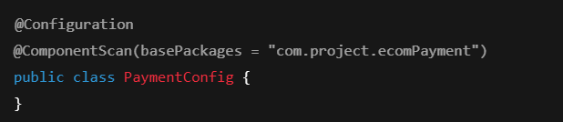
Without @Configuration, Spring ignores this class.
Why?
Because only @Configuration classes are loaded into the IoC container at startup.
Once this config is loaded, Spring includes that package in scanning.

What is @SpringBootApplication?
This is not a single annotation.
It is a combination of @SpringBootConfiguration,@EnableAutoConfiguration,@ComponentScan

@SpringBootApplication =
@SpringBootConfiguration + @EnableAutoConfiguration + @ComponentScan
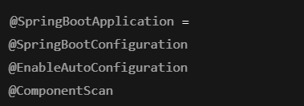

@SpringBootConfiguration
Internally:
@SpringBootConfiguration = @Configuration
It allows:
- Bean definitions
- Component scanning
- App configuration
It marks your main class as a Spring configuration class.

@EnableAutoConfiguration (Very Important)
This is what makes Spring Boot “Boot”.
Spring looks at:
- Your classpath
- Your dependencies
- Your environment
Then it auto-configures things.
Example:
If you add:
spring-boot-starter-web
Spring Boot automatically configures:
- DispatcherServlet
- Tomcat
- JSON converters
- Request mappings
You didn’t write a single line — @EnableAutoConfiguration did it.

How All This Works Together
When your app starts:
- @SpringBootApplication is found
- @SpringBootConfiguration creates IoC container
- @EnableAutoConfiguration loads required infrastructure
- @ComponentScan finds your beans
- Beans are created and wired
- Application is ready

Interview-Grade Questions
Q1. What does @ComponentScan do?
Tells Spring which packages to scan for beans.
Q2. Why is my bean not getting created?
It is outside the component scan path.
Q3. What is @SpringBootApplication internally?
A combination of Configuration, AutoConfiguration, and ComponentScan.
@SpringBootApplication =
@SpringBootConfiguration + @EnableAutoConfiguration + @ComponentScan

Q4. What does @EnableAutoConfiguration do?
Automatically configures Spring based on dependencies.

One-Line Summary
“Spring Boot starts by creating a container, auto-configuring infrastructure, and scanning packages for beans — all driven by @SpringBootApplication.”

